**Course – BCAAIML Semester – 4th**

**Subject – Computer Network Subject Code – BCAAIML403**

**Layered Architecture**

In the layered architecture of the Network Model, one whole network process is divided into small tasks. Each small task is then assigned to a particular layer, which works dedicatedly to process it only. Every layer does only specific work.

In a layered communication system, one layer of a host deals with the task done by or to be done by its peer layer at the same level on the remote host. The task is initiated by either the layer at the lowest level or the topmost level. If the topmost layer initiates the task, it is passed on to the layer below it for further processing. The lower layer does the same thing; it processes the task and passes it on to the lower layer. The reverse path is taken if the lowermost layer initiates the task.

Every layer links together all procedures, protocols, and methods required to execute its task. All layers identify their counterparts using an encapsulation header and tail.

**OSI Model**

* OSI stands for **Open System Interconnection** and is a reference model that describes how information from a [software](https://www.javatpoint.com/software) application in one [computer](https://www.javatpoint.com/what-is-computer) moves through a physical medium to the software application in another computer.
* OSI consists of seven layers, each performing a particular network function.
* The OSI model was developed by the International Organization for Standardization (ISO) in 1984, and it is now considered an architectural model for inter-computer communications.
* The OSI model divides the task into seven smaller and manageable tasks. Each layer is assigned a particular task.
* Each layer is self-contained, so tasks assigned to each layer can be performed independently.

**Various Layers of OSI Model**

* **Application Layer**: This layer providesan interface to the application user and encompasses protocols that directly interact with the user.
* **Presentation Layer**: This layer defines how data in the remote host's native format should be presented in the host's native format.
* **Session Layer**: This layer maintains sessions between remote hosts. For example, once user/password authentication is done, the remote host maintains this session for a while and does not ask for authentication again.
* **Transport Layer**: This layer is responsible for end-to-end delivery between hosts.
* **Network Layer**: This layer is responsible for address assignment and uniquely addressing hosts in a network.
* **Data Link Layer**: This layer reads and writes data from and onto the line. Link errors are detected at this layer.
* **Physical Layer**: This layer defines the hardware, cabling wiring, power output, pulse rate, etc.

**Characteristics of the OSI Model:**

* The OSI model is divided into two layers: upper layers and lower layers.
* The upper layer of the OSI model mainly deals with application-related issues, which are implemented only in the software. The application layer is closest to the end user. Both the end user and the application layer interact with the software applications. An upper layer refers to the layer just above another layer.
* The lower layer of the OSI model deals with data transport issues. The data link and physical layers are implemented in hardware and software. The physical layer is the lowest layer of the OSI model and is closest to the physical medium. It is mainly responsible for placing the information on the physical medium.

**Functions of the OSI Layers**

There are seven OSI layers. Each layer has different functions. A list of seven layers is given below:

1. Physical Layer
2. Data-Link Layer
3. Network Layer
4. Transport Layer
5. Session Layer
6. Presentation Layer
7. Application Layer

**Physical layer**

* The main functionality of the physical layer is to transmit the individual bits from one node to another.
* It is the lowest layer of the OSI model.
* It establishes, maintains and deactivates the physical connection.
* It specifies the mechanical, electrical and procedural network interface specifications.

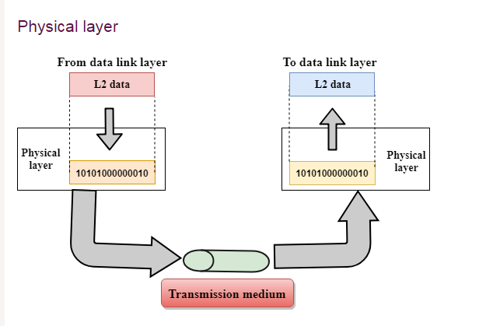

Functions of a Physical layer:

* **Line Configuration:** It defines how two or more devices can be connected physically.
* [**Data Transmission**](https://www.javatpoint.com/computer-network-transmission-modes)**:** It defines the transmission mode, whether simplex, half-duplex or full-duplex mode, between the two devices on the network.
* [**Topology**](https://www.javatpoint.com/computer-network-topologies)**:** It defines the way how network devices are arranged.
* **Signals:** It determines the type of signal used for transmitting the information.

**Data-Link Layer**

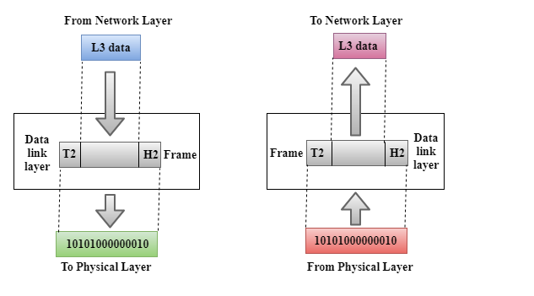

* This layer is responsible for the error-free transfer of data frames.
* It defines the format of the data on the network.
* It provides reliable and efficient communication between two or more devices.
* It is mainly responsible for uniquely identifying each device on a local network.
* It contains two sub-layers:
  + **Logical Link Control Layer**
    - It is responsible for transferring the packets to the network layer of the receiver receiving them.
    - It identifies the address of the network layer protocol from the header.
    - It also provides flow control.
  + **Media Access Control Layer**
    - A Media access control layer links the Logical Link Control layer and the network's physical layer.
    - It is used for transferring packets over the network.

**Functions of the Data-link Layer**

* **Framing:** The data link layer translates the physical's raw bit stream into packets known as Frames. The Data link layer adds the header and trailer to the frame. The header, added to the frame, contains the hardware destination and source address.

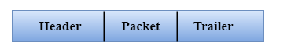

* **Physical Addressing:** The Data link layer adds a header to the frame that contains a destination address. The frame is transmitted to the destination address mentioned in the header.
* **Flow Control:** Flow control is the main functionality of the Data Link layer. It is the technique through which the constant data rate is maintained on both sides so that no data gets corrupted. It ensures that the transmitting station, such as a server with a higher processing speed, does not exceed the receiving station with a lower processing speed.
* **Error Control:** Error control is achieved by adding a calculated value CRC (Cyclic Redundancy Check) to the Data link layer's trailer, which is added to the message frame before sending it to the physical layer. If any error seems to occur, then the receiver sends anacknowledgement for the retransmission of the corrupted frames.
* **Access Control:** When two or more devices are connected to the same communication channel, the data link layer protocols determine which device controls the link at a given time.

**Network Layer**

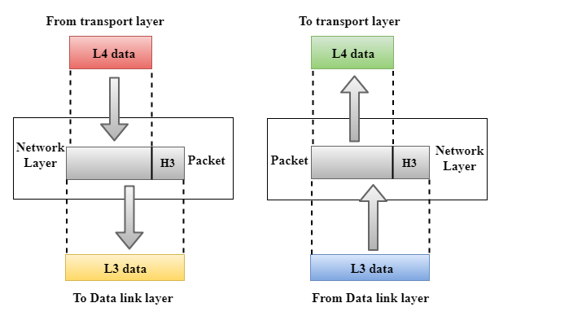

* It is layer three that manages device addressing and tracks the location of devices on the network.
* It determines the best path to move data from the source to the destination based on the network conditions, the priority of service, and other factors.
* The Data link layer is responsible for routing and forwarding the packets.
* Routers are layer three devices. They are specified in this layer and used to provide routing services within an internet network.
* The protocols used to route the network traffic are known as Network layer protocols. Examples of protocols are IP and IPv6.

**Functions of Network Layer:**

* **Internetworking:** Internetworking is the primary responsibility of the network layer. It provides a logical connection between different devices.
* [**Addressing**](https://www.javatpoint.com/network-addressing)**:** A Network layer adds the source and destination addresses to the frame's header. Addressing is used to identify a device on the Internet.
* [**Routing**](https://www.javatpoint.com/computer-network-routing)**:** Routing is asignificant component of the network layer. It determines the best optimal path from the source to the destination out of the multiple paths.
* **Packetizing:** A Network Layer receives the packets from the upper layer and converts them into packets. This process is known as Packetizing. It is achieved by internet protocol (IP).

**Transport Layer**

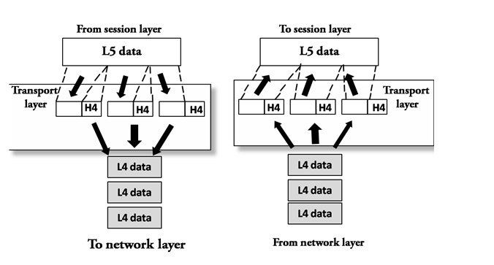

* The Transport layer, which is Layer 4, ensures that messages are transmitted in the order they are sent and that data is not duplicated.
* The primary responsibility of the transport layer is to transfer the data completely.
* It receives the data from the upper layer and converts them into smaller units known as segments.
* This layer can be termed an end-to-end layer as it provides a point-to-point connection between source and destination to deliver data reliably.

**The two protocols used in this layer are:**

* **Transmission Control Protocol**
  + It is a standard protocol that allows the systems to communicate over the internet.
  + It establishes and maintains a connection between hosts.
  + When data is sent over the TCP connection, the TCP protocol divides the data into smaller segments. Each segment travels online using multiple routes, arriving in different orders at the destination. The transmission control protocol reorders the packets correctly at the receiving end.
* **User Datagram Protocol**
  + User Datagram Protocol is a transport layer protocol.
  + It is an unreliable transport protocol as, in this case, the receiver does not send any acknowledgement when the packet is received; the sender does not wait for any acknowledgement. Therefore, this makes a protocol unreliable.

**Functions of Transport Layer:**

* **Service-point addressing:** Computers run several programs simultaneously. Due to this, data is transmitted from one source to the destination, from one computer to another and from one process to another. The transport layer adds the header containing the address known as a service point or port address. The responsibility of the network layer is to transmit the data from one computer to another computer, and the responsibility of the transport layer is to transmit the message using the correct process.
* **Segmentation and reassembly:** When the transport layer receives the message from the upper layer, it divides the message into multiple segments, and each segment is assigned a sequence number that uniquely identifies each segment. When the message arrives at the destination, the transport layer reassembles it based on its sequence numbers.
* **Connection control:** The transport layer provides two services: Connection-oriented service and connectionless service. A connectionless service treats each segment as a packet; they travel in different routes to reach the destination. A connection-oriented service connects with the transport layer at the destination machine before delivering the packets. In connection-oriented service, all the packets travel in a single route.
* **Flow control:** The transport layer is also responsible for flow control, performed end-to-end rather than across a single link.
* **Error control:** The transport layer is also responsible for Error control. Error control is performed end-to-end rather than across a single link. The sender transport layer ensures that the message reachesthe destination without error.

**Session Layer**

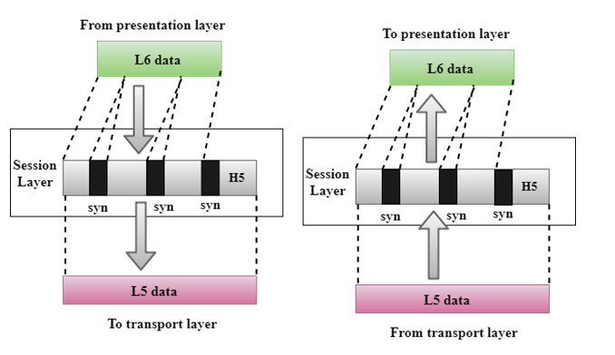

* It is a layer 3 in the OSI model.
* The Session layer establishes, maintains and synchronises the interaction between communicating devices.

**Functions of Session layer:**

* **Dialog control:** The session layer acts as a dialogue controller that creates a dialogue between two processes, or we can say that it allows communication between two processes, which can be either half-duplex or full-duplex.
* **Synchronization:** The session layer adds checkpoints when transmitting the data sequentially. If some error occurs in the middle of the data transmission, then the transmission will occur again from the checkpoint. This process is known as Synchronization and recovery.

**Presentation Layer**

* A Presentation layer mainly concerns the syntax and semantics of the information exchanged between the two systems.
* It acts as a data translator for a network.
* This layer is a part of the operating system that converts the data from one presentation format to another.
* The Presentation layer is also known as the syntax layer.

**Functions of the Presentation layer:**

* **Translation:** The processes in two systems exchange information in character strings, numbers, etc. Different computers use different encoding methods; the presentation layer handles the interoperability between the different encoding methods. It converts the data from a sender-dependent format into a standard format and changes it into a receiver-dependent format at the receiving end.
* **Encryption:** Encryption is needed to maintain privacy. It converts the sender-transmitted information into another form and sends the resulting message over the network.
* **Compression:** Data compression is a process of compressing data, i.e., reducing the number of bits to be transmitted. It is essential in multimedia, such as text, audio, and video.

**Application Layer**

* An application layer provides a window for users and application processes to access network service.
* It handles issues such as network transparency, resource allocation, etc.
* An application layer is not an application but performs the application layer functions.
* This layer provides the network services to the end-users.

**Functions of Application layer:**

* **File transfer, access, and management (FTAM):** An application layer allows a user to access the files in a remote computer, retrieve the files from a computer, and manage the files in a remote computer.
* **Mail services:** An application layer provides email forwarding and storage facility.
* Directory services: An application provides distributed database sources and is used to provide global information about various objects.

# TCP/IP model

* The TCP/IP model was developed before the OSI model.
* The TCP/IP model is not precisely similar to the OSI model.
* The TCP/IP model consists of five layers: the application layer, transport layer, network layer, data link layer and physical layer.
* The first four layers provide physical standards, network interface, internetworking, and transport functions that correspond to the first four layers of the OSI model, and these four layers are represented in the TCP/IP model by a single layer called the application layer.
* TCP/IP is a hierarchical protocol made up of interactive modules, and each of them provides specific functionality.

Hierarchy means that two or more lower-level protocols support each upper-layer protocol.

## Functions of TCP/IP layers:

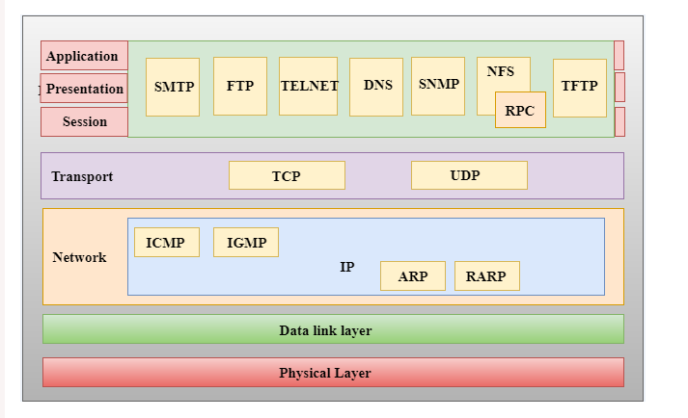

## Network Access Layer

* A network layer is the lowest layer of the TCP/IP model.
* A network layer combines the Physical and Data Link layers defined in the OSI reference model.
* It defines how the data should be sent physically through the network.
* This layer is mainly responsible for transmitting the data between two devices on the same network.
* The functions carried out by this layer are encapsulating the IP datagram into frames transmitted by the network and mapping IP addresses into physical addresses.
* The protocols used by this layer are ethernet, token ring, FDDI, X.25, and frame relay.

## Internet Layer

* An internet layer is the second layer of the TCP/IP model.
* An internet layer is also known as the network layer.
* The primary responsibility of the internet layer is to send the packets from any network, and they arrive at the destination irrespective of the route they take.

### The protocols used in this layer are:

**IP Protocol:** IP protocol is used in this layer and is the most significant part of the entire TCP/IP suite.

The following are the responsibilities of this protocol:

* **IP Addressing:** This protocol implements logical host addresses known as IP addresses. The internet and higher layers use the IP addresses to identify the device and provide internetwork routing.
* **Host-to-host communication:** It determines the path to the data's transmission.
* **Data Encapsulation and Formatting:** An IP protocol accepts the data from the transport layer protocol. An IP protocol ensures that the data is sent and received securely; it encapsulates the data into a message known as an IP datagram.
* **Fragmentation and Reassembly:** The limit imposed on the size of the IP datagram by the data link layer protocol is known as the Maximum Transmission Unit (MTU). If the size of an IP datagram is greater than the MTU unit, then the IP protocol splits the datagram into smaller units so that they can travel over the local network. The sender or intermediate router can do fragmentation. All the fragments are reassembled at the receiver side to form an original message.
* **Routing:** When an IP datagram is sent over the same local network, such as LAN, MAN, or WAN, it is known as direct delivery. The IP datagram is sent indirectly when the source and destination are on the distant network. This can be accomplished by routing the IP datagram through various devices such as routers.

**ARP Protocol**

* ARP stands for **Address Resolution Protocol**.
* ARP is a network layer protocol used to find the physical address from the IP address.
* **The two terms are mainly associated with the ARP Protocol:**
  + **ARP request:** When a sender wants to know the device's physical address, it broadcasts the ARP request to the network.
  + **ARP reply:** Every device attached to the network will accept the ARP request and process the request, but only the recipient recognises the IP address and sends back its physical address as an ARP reply. The recipient adds the physical address both to its cache memory and to the datagram header

**ICMP Protocol**

* **ICMP** stands for Internet Control Message Protocol.
* It is a mechanism the hosts or routers use to send notifications regarding datagram problems back to the sender.
* A datagram travels from router to router until it reaches its destination. Suppose a router cannot route the data because of unusual conditions such as disabled links, a device being on fire or network congestion. In that case, the ICMP protocol informs the sender that the datagram is undeliverable.
* An ICMP protocol mainly uses two terms:
  + **ICMP Test:** The ICMP Test tests whether the destination is reachable.
  + **ICMP Reply:** ICMP Reply checks whether the destination device is responding.
* The ICMP protocol's core responsibility is to report problems, not to correct them. The sender is responsible for correcting the problems.
* ICMP can send messages only to the source but not to the intermediate routers because the IP datagram carries the addresses of the source and destination but not the router to which it is passed.

## Transport Layer

The transport layer is responsible for the reliability, flow control, and correction of data sent over the network.

Prime Ministers of India | List of Prime Ministers of India (1947-2020)

The two protocols used in the transport layer are **the User Datagram Protocol and the Transmission Control Protocol**.

* **User Datagram Protocol (UDP)**
  + It provides connectionless service and end-to-end transmission delivery.
  + It is an unreliable protocol as it discovers the errors but does not specify the error.
  + User Datagram Protocol discovers the error, and ICMP protocol reports the error to the sender that the user datagram has been damaged.
  + **UDP consists of the following fields:**  
    **Source port address:** The source port address is the address of the application program that has created the message.  
    **Destination port address:** The destination port address is the address of the application program that receives the message.  
    **Total length:** It defines the total number of bytes of the user datagram in bytes.  
    **Checksum:** The checksum is a 16-bit field used in error detection.
  + UDP does not specify which packet is lost. UDP contains only checksum; it does not contain any ID of a data segment.

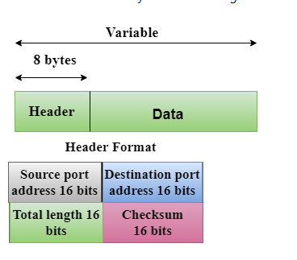

* **Transmission Control Protocol (TCP)**
  + It provides a complete transport layer services to applications.
  + It creates a virtual circuit between the sender and receiver and is active for the duration of transmission.
  + TCP is a reliable protocol as it detects errors and retransmits the damaged frames. Therefore, it ensures all the segments are received and acknowledged before the transmission is completed, and a virtual circuit is discarded.
  + At the sending end, TCP divides the whole message into smaller units known as segments, and each segment contains a sequence number, which is required for reordering the frames to form an original message.
  + At the receiving end, TCP collects all the segments and reorders them based on sequence numbers.

## Application Layer

* An application layer is the topmost TCP/IP model layer.
* It is responsible for handling high-level protocols and issues of representation.
* This layer allows the user to interact with the application.
* When one application layer protocol wants to communicate with another, it forwards its data to the transport layer.
* An ambiguity occurs in the application layer. Every application except those interacting with the communication system cannot be placed inside the application layer. For example, the application layer cannot consider a text editor. At the same time, web browsers use HTTP protocol to interact with the network, where **HTTP** protocol is an application layer protocol.

### The following are the primary protocols used in the application layer:

* **HTTP:** HTTP stands for Hypertext transfer protocol. This protocol allows us to access the data over the World Wide Web. It transfers the data in plain text, audio, and video. It is known as a hypertext transfer protocol as it is efficient for use in a hypertext environment with rapid jumps from one document to another.
* **SNMP:** SNMP stands for Simple Network Management Protocol. It is a framework used to manage the devices on the internet using the TCP/IP protocol suite.
* **SMTP:** SMTP stands for Simple mail transfer protocol. The TCP/IP protocol that supports the e-mail is known as a Simple mail transfer protocol. This protocol is used to send the data to another e-mail address.
* **DNS:** DNS stands for Domain Name System. An IP address is used to identify the connection of a host to the internet uniquely. But people prefer to use names instead of addresses. Therefore, the system that maps the name to the address is known as the Domain Name System.
* **TELNET:** It is an abbreviation for Terminal Network. It establishes the connection between the local computer and the remote computer so that the local terminal appears to be a terminal in the remote system.
* **FTP:** FTP stands for File Transfer Protocol. FTP is a standard internet protocol for transmitting files from one computer to another.

**Modulation**

**Modulation** is the process of varying one or more parameters of a carrier signal by the instantaneous values of the message signal.

The message signal is being transmitted for communication, and the carrier signal is a high-frequency signal that has no data but is used for long-distance transmission.

There are many modulation techniques, which are classified according to the type of modulation employed. Of them all, the digital modulation technique used is **Pulse Code Modulation**PCM.

A signal is a pulse code modulated to convert its analogue information into a binary sequence, i.e., **1s** and **0s**. The output of a PCM will resemble a binary sequence. The following figure shows an example of PCM output concerning instantaneous values of a given sine wave.

Instead of a pulse train, PCM produces a series of numbers or digits; hence, this process is called digital. Each digit, though in binary code, represents the approximate amplitude of the signal sample at that instant.

In Pulse Code Modulation, the message signal is represented by a sequence of coded pulses. This message signal is achieved by representing the signal in discrete form in both time and amplitude.

## Basic Elements of PCM

The transmitter section of a Pulse Code Modulator circuit consists of **Sampling, Quantizing**, and Encoding, which are performed in the analog-to-digital converter section. The low-pass filter prior to sampling prevents the message signal from aliasing.

The basic operations in the receiver section are regenerating impaired signals, decoding, and reconstructing the quantised pulse train. The following is the block diagram of PCM, which represents the basic elements of both the transmitter and the receiver sections.

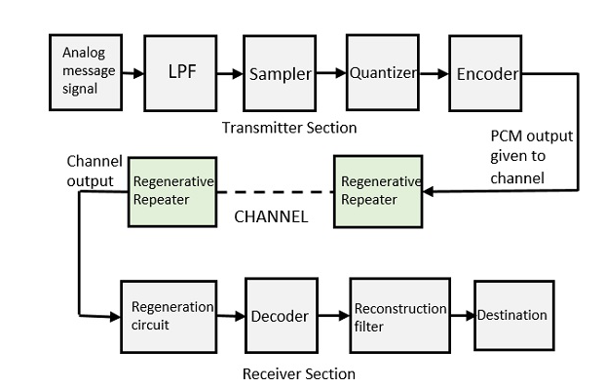

### Low Pass Filter

* This filter eliminates the high-frequency components present in the input analogue signal, which is greater than the highest frequency of the message signal, to avoid aliasing of the message signal.

### Sampler

* This technique helps collect the sample data at instantaneous values of the message signal so as to reconstruct the original signal. The sampling rate must be greater than twice the highest frequency component **W** of the message signal by the sampling theorem.

### Quantizer

* Quantizing is reducing the excessive bits and confining the data. When given to Quantizer, the sampled output reduces the redundant bits and compresses the value.

### Encoder

* The encoder does the digits of the analogue signals. It designates each quantised level by a binary code. The sampling done here is the sample-and-hold process. These three sections, LPF, Sampler, and quantiser, will act as analogues to digital converters. Encoding minimises the bandwidth used.

### Regenerative Repeater

* This section increases the signal strength. The channel's output also has one regenerative repeater circuit to compensate for the signal loss, reconstruct the signal, and increase its strength.

### Decoder

The decoder circuit decodes the pulse-coded waveform to reproduce the original signal. This circuit acts as the demodulator.

### Reconstruction Filter

* After the regenerative circuit and the decoder does the digital-to-analogue conversion, a low-pass filter, called the reconstruction filter, is employed to return the original signal.
* Hence, the Pulse Code Modulator circuit digitises the given analogue signal, codes and samples it, and then transmits it in an analogue form. This process is repeated in a reverse pattern to obtain the original signal.

**Differential Pulse Code Modulation (DPCM):**   
DPCM is the same as the PCM technique for remodelling analogue signals into digital ones. DPCM has a moderate signal-to-noise ratio.

* DPCM differs from PCM because it quantises the distinction between the particular sample and the expected price. That’s the explanation for why it’s referred to as differential PCM.
* The operations at the DPCM transmitter and DPCM receiver are given below inthe figure:

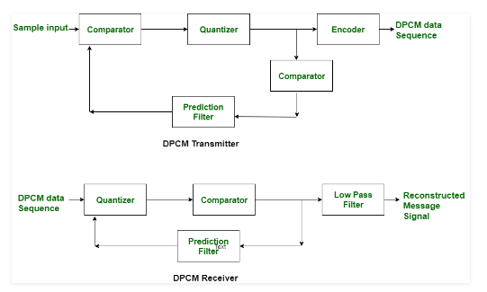

Difference between PCM and DPCM

| S.NO | PCM | DPCM |
| --- | --- | --- |
| 1. | PCM stands for Pulse Code Modulation. | Meanwhile, DPCM stands for differential pulse code modulation. |
| 2. | In PCM, feedback is not provided. | While in DPCM, feedback is provided. |
| 3. | It has a good signal-to-noise ratio. | While it has a moderate signal-to-noise ratio. |
| 4. | It is less efficient than DPCM. | While it is more efficient than PCM. |
| 5. | For transmission channels, PCM needs high bandwidth(B). | Whereas DPCM needs less bandwidth(B) than PCM. |
| 6. | PCM is more complex than DPCM in terms of complexity. | While DPCM is simple in terms of complexity. |
| 7. | In PCM, seven bits are transmitted per eight samples. | In DPCM, four bits are transmitted per six samples. |
| 8. | In PCM, the transmitting bits rate varies from fifty-five to sixty-four. | In DPCM, the transmitting bits rate varies from thirty-two to forty-eight. |

**Delta Modulation (DM):**

Delta modulation is associated with analogue-to-digital and digital-to-analogue signal conversion techniques. Delta modulation is utilised to appreciate high signal-to-noise magnitude relations. It uses a one-bit PCM code to enjoy the digital transmission of the analogue signals. With delta modulation, rather than transmitting a coded illustration of a sample, only one bit is transmitted, indicating whether the sample is larger or smaller than the previous sample. It’s the most effective or straightforward differential pulse code modulation. The Delta modulation signal is smaller than the Pulse Code Modulation system.

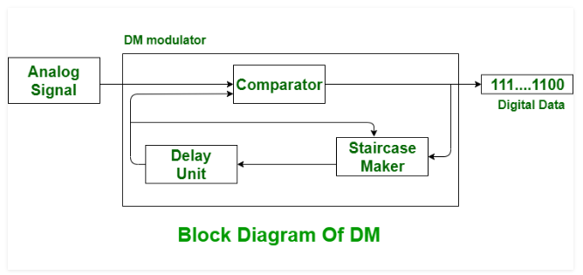

## What is a Multiplexing?

Muxing (or multiplexing) is a way of transmitting various signals over a medium or single line. A common kind of multiplexing merges a number of low-speed signals to send over only a high-speed link, or it is used to transmit a medium and its link with a number of devices. It provides both privacy and efficiency.

The entire process can be done using a device called MUX or multiplexer. The primary function of this device is to unite n-input lines to generate a single output line. Thus, MUX has many inputs and a single output. A device called DEMUX or demultiplexer is used at the receiving end, which divides the signal into its component signals. So, it has a single input and a number of outputs.

The primary function of the transmission medium is to transmit the signals from transmitter to receiver. Here, the medium includes a single signal at a time. So, if several signals need to communicate a single medium, they should be separated so that each signal is given some part of the obtainable bandwidth.

For instance,If there are five signals & the medium bandwidth is 50 units, then the five units can be shared through every signal. Once multiple signals transmit the common medium, there is a chance of a crash. So, the concept of this technique is mainly used to evade such crashes.

## Types of Multiplexing Techniques

These techniques are mainly[used in communication](https://www.elprocus.com/types-of-wireless-communication-applications/), and these are classified into three types. The **three types of multiplexing** techniques include the following.

* Frequency Division Multiplexing (FDM)
* Wavelength Division Multiplexing (WDM)
* Time Division Multiplexing (TDM)

### Frequency Division Multiplexing (FDM)

In the 20th century, telephone companies used FDM in long-distance connections to multiplex a number of voice signals using a system like a coaxial cable. For small distances, low-cost cables were utilised for different systems such as bell systems and K- and N-carriers; however, they don’t allow huge bandwidths. This is analogue multiplexing used to unite analogue signals. This type of technique is proper when the link’s bandwidth is better than the United bandwidth of the transmitted signals.

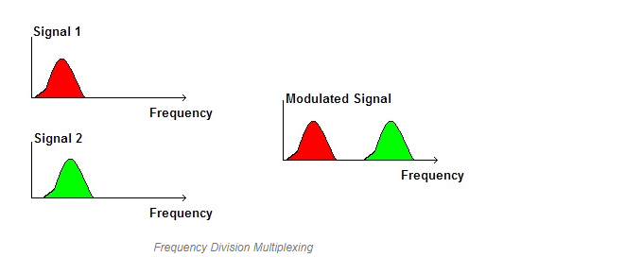

In FDM, signals are produced by transmitting various device-modulated carrier frequencies, and then these are united into a solo signal thatthe connection can move. To hold the adapted signal, the carrier frequencies are divided by sufficient bandwidth, and these ranges of bandwidths are the channels through the different travelling signals. These can be divided by bandwidth that is not used. The best examples of FDM comprise signal transmission in TV and radio.

### Wavelength Division Multiplexing (WDM)

In **fibre communications**, the WDM is one type of technology. This is the most helpful concept in high-capacity [communication systems](https://www.elprocus.com/phase-locked-loop-system-in-communication-systems/). At the end of the transmitter section, the multiplexer is used to combine the signals. At the end of the receiver section, the de-multiplexer divides the signals separately. The primary function of WDM at the multiplexer is to unite various light sources into only light sources, and this light can be changed into numerous light sources at the de-multiplexer.

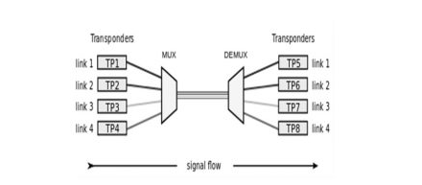 WDM

The main intention of WDM is to utilise the high data rate capacity of the[FOC (fibre optic cable)](https://www.elprocus.com/basic-elements-of-fiber-optic-communication-system-and-its-working/). The high data rate of this FOC cable is superior to the data rate of the metallic transmission cable. Theoretically, the WDM is similar to the FDM, apart from the data transmission through the FOC in which the multiplexing & de-multiplexing occupy optical signals. Please refer to the link to learn about [**Wavelength Division Multiplexing (WDM) Working and Applications**](https://www.elprocus.com/understanding-wavelength-division-multiplexing-wdm/)**.**

### Time Division Multiplexing (TDM)

The TDM is one method for transmitting a signal over a particular communication channel by separating the time edge into slots, likea single slot is used for each message signal.

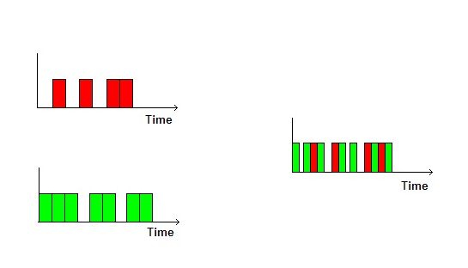**Time Division Multiplexing**

TDM is mainly helpful for [analogue](https://www.elprocus.com/difference-between-analog-circuit-and-digital-circuit/) signals, in which several low-speed channels are multiplexed into high-speed channels for transmission. Depending on the time, every low-speed channel will be assigned to an exact position, wherever it works in the synchronisation mode. Both the ends of **MUX and DEMUX** are synchronisedin a timely manner and switch toward the next channel at the same time.

#### Statistical TDM

The statistical TDM is applicable to transmitting different data types simultaneously across a single cable. It is frequently used to handle transmitted data through a network like a LAN (or) WAN. Data can be transmitted from input devices connected to networks like computers, fax machines, printers, etc.

The statistical TDM can be used to control calls in the settings of telephone switchboards. This technique is comparable to dynamic bandwidth distribution, in which a communication channel is separated into a random data stream number.

**Transmission media**

* Transmission media is a communication channel that carries the information from the sender to the receiver. Data is transmitted through the electromagnetic signals.

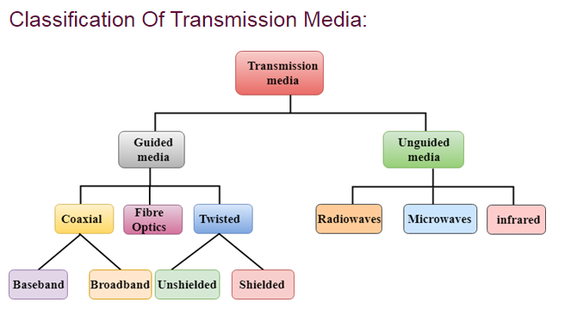

# Guided Media

It is defined as the physical medium through which the signals are transmitted. It is also known as Bounded media.

**Types Of Guided Media:**

## Twisted pair:

A twisted pair is a physical media made up of twisted cables. It is cheap compared to other transmission media, easy to install, and lightweight. The frequency range for twisted pair cables is from 0 to 3.5KHz.

A twisted pair consists of two insulated copper wires arranged in a regular spiral pattern.

The degree of reduction in noise interference is determined by the number of turns per foot. Increasing the number of turns per foot decreases noise interference.

**Types of Twisted pair:**

Difference between JDK, JRE, and JVM

### Unshielded Twisted Pair:

An unshielded twisted pair is widely used in telecommunication. Following are the categories of the unshielded twisted pair cable:

* **Category 1:** Category 1 is used for telephone lines that have low-speed data.
* **Category 2:** It can support up to 4Mbps.
* **Category 3:** It can support up to 16Mbps.
* **Category 4:** It can support up to 20Mbps. Therefore, it can be used for long-distance communication.
* **Category 5:** It can support up to 200Mbps.

**Advantages of Unshielded Twisted Pair:**

* It is cheap.
* Installation of the unshielded twisted pair is easy.
* It can be used for high-speed LAN.

**Disadvantage:**

* This cable can only be used for shorter distances because of attenuation.

### Shielded Twisted Pair

A shielded twisted pair is a cable that contains mesh surrounding the wire, which allows a higher transmission rate.

**Characteristics of Shielded Twisted Pair:**

* The cost of the shielded twisted pair cable is not very high and not very low.
* An installation of STP is easy.
* It has a higher capacity than unshielded twisted pair cables.
* It has a higher attenuation.
* It is shielded, which provides a higher data transmission rate.

**Disadvantages**

* It is more expensive than UTP and coaxial cable.
* It has a higher attenuation rate.

## Coaxial Cable

* Coaxial cable is a very commonly used transmission media; for example, a TV wire is usually a coaxial cable.
* The name of the cable is coaxial, as it contains two conductors parallel to each other.
* It has a higher frequency than aTwisted pair cable.
* The inner conductor of the coaxial cable is made up of copper, and the outer conductor is made up of copper mesh. The middle core comprisesa non-conductive cover separatingthe inner and outer conductors.
* The middle core is responsible for the data transfer, whereas the copper mesh prevents the **EMI** (Electromagnetic interference).

**Coaxial cable is of two types:**

1. **Baseband transmission:** It is defined as the process of transmitting a single signal at high speed.
2. **Broadband transmission:** It is defined as the process of transmitting multiple signals simultaneously.

**Advantages Of Coaxial Cable:**

* The data can be transmitted at high speed.
* It has better shielding than twisted pair cables.
* It provides higher bandwidth.

**Disadvantages Of Coaxial cable:**

* It is more expensive than a twisted pair cable.
* If any fault occurs in the cable, it causes the failure in the entire network.

## Fiber Optic

* Fiber optic cable is a cable that uses electrical signals for communication.
* Fiber optic is a cable that holds the optical fibres coated in plastic to send the data by light pulses.
* The plastic coating protects the optical fibres from heat, cold, and electromagnetic interference from other types of wiring.
* Fiber optics provide faster data transmission than copper wires.

**Essential elements of Fiber optic cable:**

* **Core:** The optical fibre consists of a narrow strand of glass or plastic called a core. A core is a light transmission area of the fibre. The more the area of the core, the more light will be transmitted into the fibre.
* **Cladding:** The concentric layer of glass is known as cladding. The main functionality of the cladding is to provide the lower refractive index at the core interface to cause the reflection within the core so that the light waves are transmitted through the fibre.
* **Jacket:** The protective coating consisting of plastic is known as a jacket. The primary purpose of a jacket is to preserve the strength of the fibre, absorb shock, and provide extra fibre protection.

**The following are the advantages of fibre optic cable over copper:**

* **Greater Bandwidth:** The fibre optic cable provides more bandwidth than copper. Therefore, fibre optics carry more data than copper cables.
* **Faster speed:** Fibre optic cable carries the data as light. This allows the fibre optic cable to carry the signals faster.
* **Longer distances:** The fibre optic cable carries the data at a longer distance than the copper cable.
* **Better reliability:** The fibre optic cable is more reliable than the copper cable as it is immune to temperature changes. At the same time, it can obstruct the connectivity of copper cables.

# ****Thinner and Sturdier:**** Fibre optic cable is thinner and lighter, so it can withstand more pull pressure than copper cable. Unguided Transmission

* An unguided transmission transmits electromagnetic waves without using any physical medium. Therefore, it is also known as **wireless transmission**.
* In unguided media, air is the media through which the electromagnetic energy can flow easily.

Unguided transmission is broadly classified into three categories:

## Radio waves

* Radio waves are electromagnetic waves transmitted in all the directions of free space.
* Radio waves are omnidirectional, i.e., the signals are propagated in all directions.
* The range in frequencies of radio waves is from 3Khz to 1 kHz.
* In the case of radio waves, the sending and receiving antenna are not aligned, i.e., the wave sent by the sending antenna can be received by any receiving antenna.
* An example of a radio wave is **FM radio**.

**Applications Of Radio waves:**

* A Radio wave is helpful for multicasting when there is one sender and many receivers.
* An FM radio, television, and cordless phones are examples of a radio wave.

**Advantages Of Radio transmission:**

* Radio transmission is mainly used for wide area networks and mobile cellular phones.
* Radio waves cover a large area, and they can penetrate the walls.
* Radio transmission provides a higher transmission rate.

## Microwaves

Microwaves are of two types:

* Terrestrial microwave
* Satellite microwave communication.

### Terrestrial Microwave Transmission

* Terrestrial Microwave transmission is a technology that transmits the focused beam of a radio signal from one ground-based microwave transmission antenna to another.
* Microwaves are electromagnetic waves with a frequency ranging from 1GHz to 1000 GHz.
* Microwaves are unidirectional as the sending and receiving antenna is to be aligned, i.e., the waves sent by the sending antenna are narrowly focused.
* In this case, antennas are mounted on the towers to send a beam to another antenna km away.
* It works on the line of sight transmission, i.e., the antennas mounted on the towers are the direct sight of each other.

**Characteristics of Microwave:**

* **Frequency range:** Terrestrial microwaves are from 4-6 GHz to 21-23 GHz.
* **Bandwidth:** It supports the bandwidth from 1 to 10 Mbps.
* **Short distance:** It is inexpensive for short distance.
* **Long distance:** It is expensive as it requires a higher tower for a longer distance.
* **Attenuation:** Attenuation means loss of signal. It is affected by environmental conditions and antenna size.

**Advantages of Microwave:**

* Microwave transmission is cheaper than using cables.
* It is free from land acquisition as it does not require any land to install cables.
* Microwave transmission provides accessible communication in terrains where cable installation is complicated.
* Communication over oceans can be achieved by using microwave transmission.

**Disadvantages of Microwave transmission:**

* **Eavesdropping:** Eavesdropping creates insecure communication. Any malicious user can catch the signal in the air using its antenna.
* **Out-of-phase signal:** A signal can be moved out of phase using microwave transmission.
* **Susceptible to weather conditions: A microwave transmission is susceptible to weather conditions**. Any environmental change, such as rain or wind, can distort the signal.
* **Bandwidth limited:** Allocation of bandwidth is limited in the case of microwave transmission.

### Satellite Microwave Communication

* A satellite is a physical object that revolves around the Earth at a known height.
* Satellite communication is more reliable nowadays, offering more flexibility than cable and fibre optic systems.
* We can communicate at any point on the globe using satellite communication.

**How Does Satellite Work?**

The satellite accepts the signal transmitted from the earth station, amplifies it, and retransmits the amplified signal to another earth station.

**Advantages of Satellite Microwave Communication:**

* The coverage area of a satellite microwave is more than that of a terrestrial microwave.
* The transmission cost of the satellite is independent of the distance from the centre of the coverage area.
* Satellite communication is used in mobile and wireless communication applications.
* It is easy to install.
* It is used in various applications such as weather forecasting, radio/TV signal broadcasting, mobile communication, etc.

**Disadvantages of Satellite Microwave Communication:**

* Satellite designing and development requires more time and higher cost.
* The Satellite needs to be monitored and controlled on regular periods so that it remains in orbit.
* The satellite's life is about 12-15 years. Because of this, another launch of the satellite has to be planned before it becomes non-functional.

## Infrared

* An infrared transmission is a wireless technology used for communication over short ranges.
* The infrared frequencyranges from 300 GHz to 400 THz.
* It is used for short-range communication, such as data transfer between two cell phones, TV remote operation, and data transfer between a computer and cell phone residing in the same closed area.

**Characteristics of Infrared:**

* It supports high bandwidth so that the data rate will be very high.
* Infrared waves cannot penetrate walls, so infrared communication in one room cannot be interrupted by the nearby rooms.
* An infrared communication provides better security with minimum interference.
* Infrared communication is unreliable outside the building because the sun's rays will interfere with the infrared waves.